Error : UnicodeDecodeError : ‘charmap’ codec can’t decode byte 0x8f in position 182

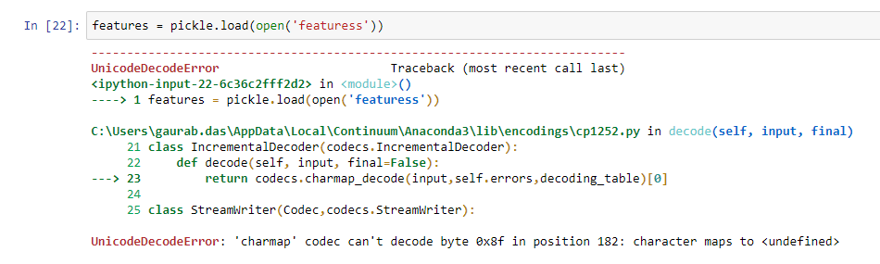

Solution : features = pickle.load(open( ‘features’ , ‘rb’ ) )

Note :

r+ is used for reading, and writing mode. b is for binary. r+b mode is open the binary file in read or write mode.